Amba Sharma 239016244

Markov Processes
Ma2404

Introduction
This project focuses on determining the expected value of stocks invested by a 60-year-old man in a single company, which will be inherited by his daughter upon his death. The objective is to calculate the distribution of the future value of these stocks, considering the uncertainty in both the lifespan of the individual and the fluctuations in stock prices. My analysis involves modelling the man's remaining lifespan using the Gompertz distribution, selecting and analysing the historical performance of Tesco, and applying Monte Carlo simulations to compute and visualize the distribution of the inheritance value.

Assumptions
- Parameters of Gompertz distribution are accurately estimated by using UK mortality data.
- The mortality data is reliable representation of the lifespan distribution for the 60-year-old man.
- The stock values follow the normal distribution.

Methodology

Part One (i)
Literature Review for the distribution of N

For part one I need to find the estimation of the distribution of N. N is the number of years the man will live from now (rounded to the nearest integer). There are three options to choose from: exponential, Weibull, and Gompertz distribution.

There are many key characteristics of exponential distribution. The first one is its constant hazard rate, this means the failure rate remains constant over time. The second is that exponential distribution has a memoryless property. This is where the future behaviour of a random variable is independent from its past. The third key characteristic is that it has a single parameter. It is defined by a single parameter (lambda) which represents the rate of events. It also has a continuous distribution, modelling continuous nonnegative events such as waiting times or lifetimes. Exponential distribution is used in various lifespan modelling scenarios such as the lifetimes of electronic components. Due its single parameter and straightforward formulae, it would be a good option to choose to model the distribution of N. However, the memoryless property is not realistic for modelling human lifespans. Human lifetimes are not independent events therefore it would be an improper model to choose for this distribution.

The Weibull distribution could be selected to model the distribution. The Weibull distribution is known for its flexibility as it can take of the characteristics of other types of distributions based on its shape parameters. It has two main parameters, shape and scale. The shape parameter affects the distribution’s shape and failure rate behaviour, and the scale parameter influences the spread of the distribution. The model can have an increasing or decreasing hazard rates based on the shape parameter. It is widely used in reliability analysis to model failure times and assess product reliability. It can be used to model life data analysis as it effectively captures various life behaviours and failure modes. However, its strengths align with industrial and mechanical applications as the distribution is more suited for modelling single causes of death rather than grouped data. It also assumes independence, which is not the case for modelling human lifespans. Therefore, the distribution I selected is Gompertz distribution.

The Gompertz distribution key characteristic is that it has an exponentially increasing hazard rate which aligns with human mortality patterns. It has two main parameters: scale and shape. The scale parameter influences the rate of mortality level, and the shape parameter affects the initial mortality level. It has a flexible distribution with the ability to be skewed left or right. It is specifically designed for describing the distribution of adult deaths in demography and actuarial science. It is used to examine trends in human longevity across different populations and time periods. This means that the Gompertz distribution is the most appropriate choice for modelling the remaining lifespan N of the 60-year-old man in the UK. The only limitations of using this model it may not accurately model mortality at very old ages and that the parameter estimation can be challenging particularly with limited data.

Parameter estimation for N

I used the national life tables (Buxton, 2024 ) to determine the parameters of the Gompertz distribution and initially did this by methods of moments. This is a technique to estimate parameters of a probability distribution by matching sample moments with population moments. The first sample moment is expectation which is given in the data, I used the most recent year 2022, for my value which was 22.23. The second sample moment or the variance can be calculated by the formula E[T^2] – E[T] where ‘t’ denotes how long men live after 60 years old. Using Excel, I calculated my variance which was 57.42 (2dp). Then I was going to compare it with the population moments by solving the two simultaneous equations.
E[X] = 22.23 = $\frac{1}{b}e^{\frac{a}{b}}(\frac{a}{b}-Log\left(\frac{a}{b}\right)-γ )$
Var[X] = 57.42 (2dp) = $\frac{1}{b}*\frac{π^{2}}{6}-\frac{2a}{b^{3}}$
(Lenart, 2011)
However, I could not figure out how to solve these equations, so I switched the method used to method of maximum likelihood. I designed a code in R-studio to compute my values, imported the data and created the Gompertz distribution to be a function in my code. I calculated the log - likelihood and had an initial first guess at what my parameters would be. Then I optimized my results to find a point where it converged which resulted in finding parameters. The results for η = 0.0016 and β = 0.5341. (Figure One)

Part Two

I selected the company, Tesco, with historical prices for the last ten years 2014 – 2024. I used the method of percentiles to estimate the parameters then found the average stock price and calculated my $X_{i}$ values, ordering them from smallest to greatest. I chose $α_{1}$ and $α_{2}$ to be 25% and 75% and then found my Q values to be -0.069 (3dp) and 0.001(3dp). I chose my α values with the intention of focusing on the range where the central 50% of the data lies, to avoid the influence of extreme values which can distort the estimation of my parameters. Stocks can have significant variability, by focusing on the interquartile range it shows the typical changes in the stock prices whilst ignoring outliers. As I have assumed that $X_{i}$ has followed the normal distribution, I used the tables to find my z values which were -0.6745 and 0.6745 respectively. I needed to use the z values to link the percentile ranks to the actual data values using the properties of the normal curve. The mean value was -0.034 (3dp) and my standard deviation was 0.052 (3dp). Therefore, these are my parameters. (Figure Two)

It can be inferred that the negative mean value suggests a slight average decline in the logarithmic returns implying, on average, the stock prices are expected to decrease over time. The small standard deviation indicates relatively low variability in the logarithmic returns, the value of the investment over time, meaning the stock price changes are not highly volatile. The low values from both the mean and the standard deviation show that Tesco’s stock price is relatively stable with minor expected losses.

Part Three

Using my parameters from the first two parts, I then conducted the Monte Carlo simulation to compute a mean, variance and the distribution of logS. Monte Carlo simulation is a computational algorithm that uses repeated random sampling to obtain the likelihood of a range of results of occurring. It assesses the impact of risk in real life scenarios such as stock prices. (IBM, 2023). I ran the Monte Carlo simulation 1000 times and consequently gathered a mean and variance. Again, I used R-studio to find the values (Figure Three) for my mean which was 6.8752 (4dp) and the variance was 0.0038 (4dp). I needed to contextualise these numbers, so I equated my mean to logS and calculated $e^{6.8752}$ which is approximately 967.96894. This implies, on average, the inheritance sum is expected to be close to the initial investment. However, it is less than the original sum therefore indicating that the stocks have lost value over the time period. The variance is low, suggesting that the actual inheritance sum is likely to fall close to the average value of 967.96894. This reflects the stability in the stock returns and reduced uncertainty in the number of years N.

I also created a histogram of the Monte Carlo simulation (Figure Four) to display the data which provides a visual representation of the distribution. The graph peaks near 6.875 which aligns with the mean of log S and most of the values are concentrated around this point. The width of the histogram along with the low variance reflects again that the values are tightly clustered around the mean. This implies low variability in the inheritance. The values of log S appear to range between 6.65 and 7 with the majority appearing between 6.8 and 6.9. This also confirms that extreme deviations from the mean are unlikely.

Conclusion

By picking the Gompertz distribution and using method of maximum likelihood I calculated the parameters η = 0.0016 and β = 0.5341. Then I used method of percentiles to calculate my stock prices and estimated the parameters to be μ = -0.034 and the σ = 0.052. Using these parameters. I computed the mean and variance and distribution for the logS by performing the Monte Carlo simulation and figured out the estimate of the sum the daughter will inherit to be 968.743625. This is realistic estimate as it is close to the original sum of 1000.

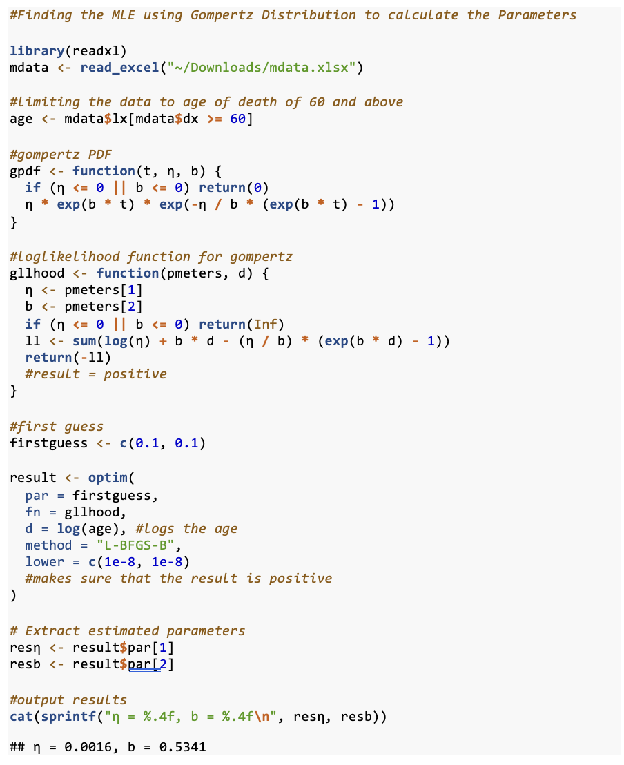
Appendix

Figure One:
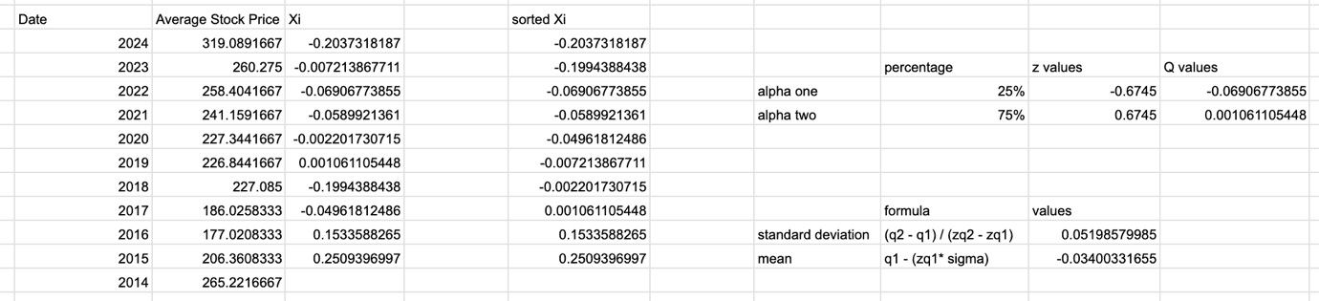
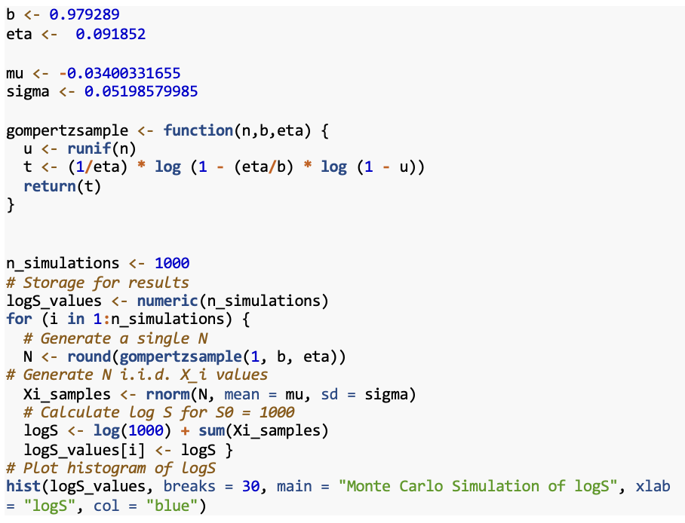
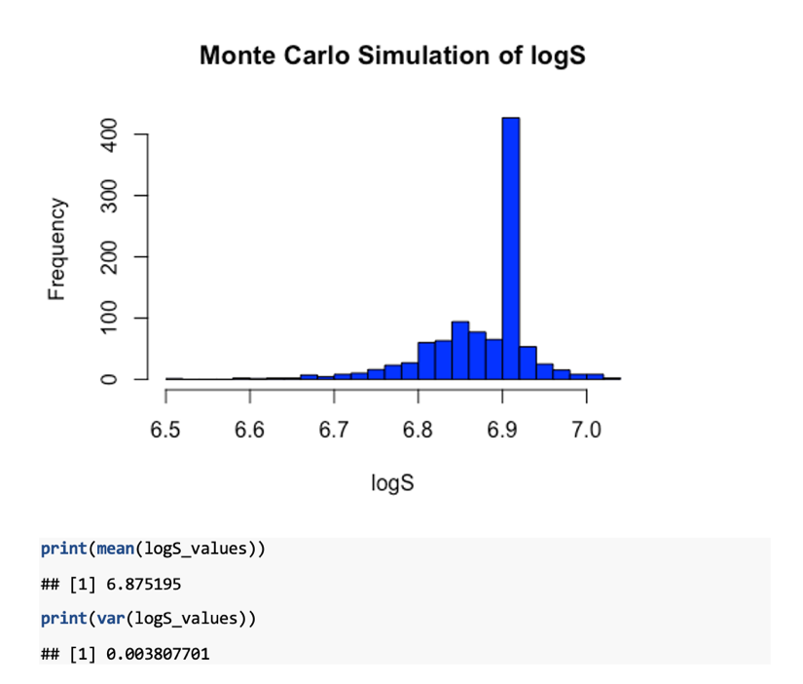
Figure Two:

Figure Three:

Figure Four:

Reference list
Buxton , J. (2024). National Life tables: Great Britain - Office for National Statistics. [online] www.ons.gov.uk. Available at: https://www.ons.gov.uk/peoplepopulationandcommunity/birthsdeathsandmarriages/lifeexpectancies/datasets/nationallifetablesgreatbritainreferencetables.
IBM (2023). What is Monte Carlo Simulation? | IBM. [online] www.ibm.com. Available at: https://www.ibm.com/topics/monte-carlo-simulation.
Investing.com. (n.d.). Tesco PLC Historical Price Data (TSCO). [online] Available at: https://www.investing.com/equities/tesco-historical-data.
Lenart, A. (2012). The moments of the Gompertz distribution and maximum likelihood estimation of its parameters. Scandinavian Actuarial Journal, 2014(3), pp.255–277. doi:https://doi.org/10.1080/03461238.2012.687697.
Rdocumentation.org. (2019). sprintf function - RDocumentation. [online] Available at: https://www.rdocumentation.org/packages/base/versions/3.6.2/topics/sprintf.
WiseRohin (2022). Optim() function in R. [online] Stack Overflow. Available at: https://stackoverflow.com/questions/70678537/optim-function-in-r.
Yates, T., Summerfield, A., Razieh, C., Banerjee, A., Chudasama, Y., Davies, M.J., Gillies, C., Islam, N., Lawson, C., Mirkes, E., Zaccardi, F., Khunti, K. and Nafilyan, V. (2022). A population-based cohort study of obesity, ethnicity and COVID-19 mortality in 12.6 million adults in England. Nature Communications, 13(1). doi:https://doi.org/10.1038/s41467-022-28248-1.

